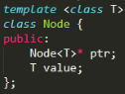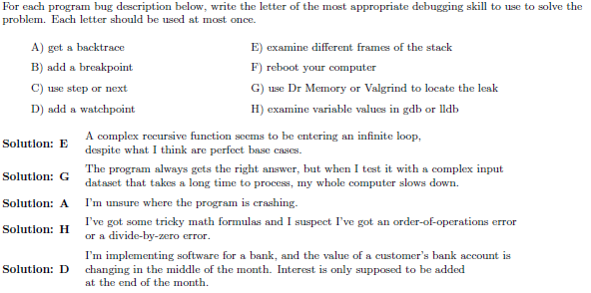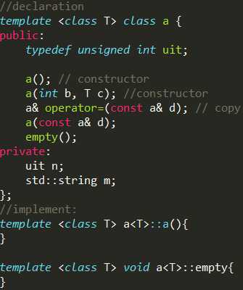

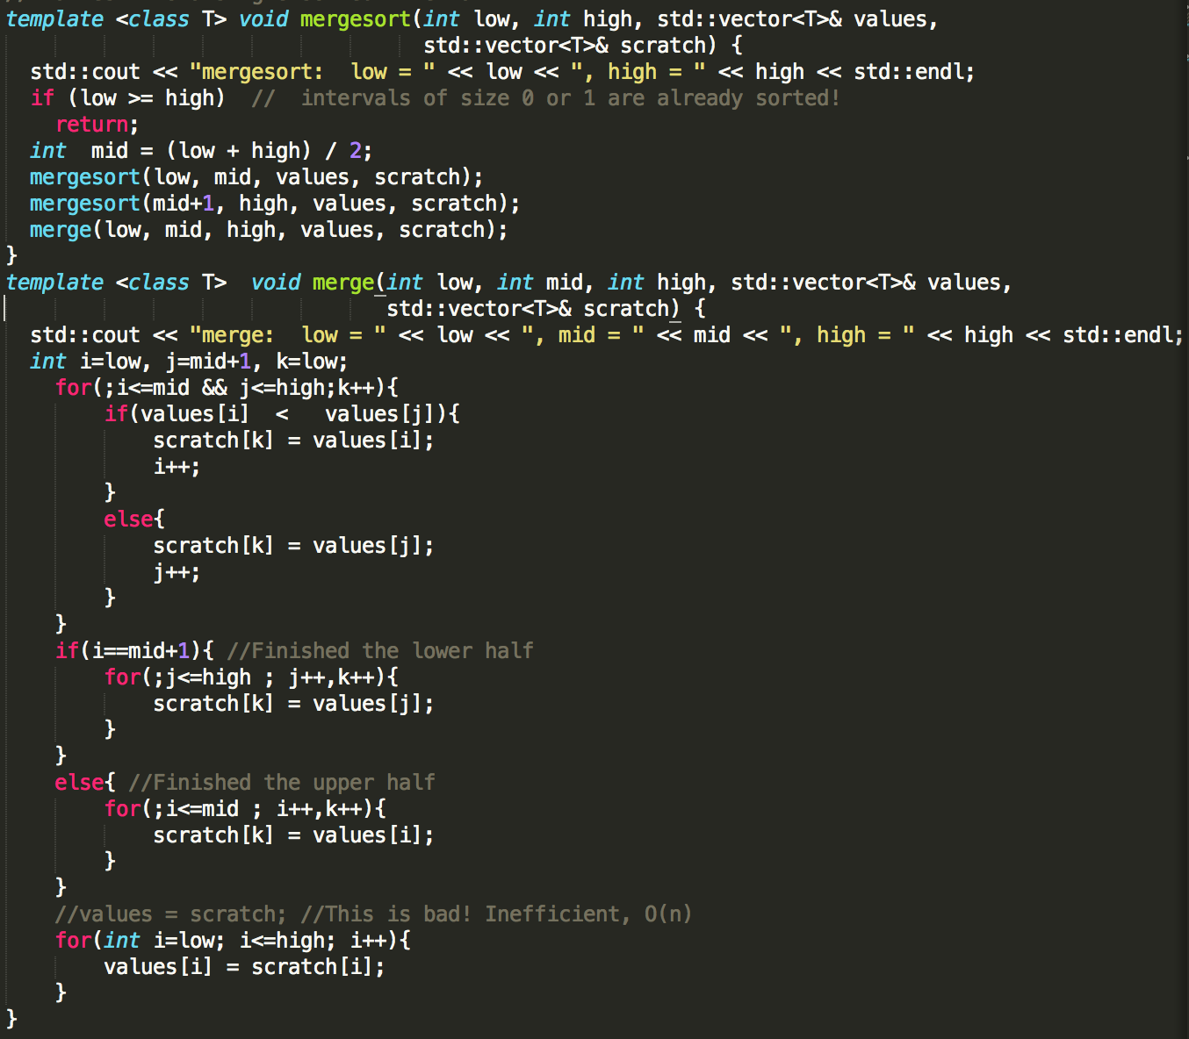

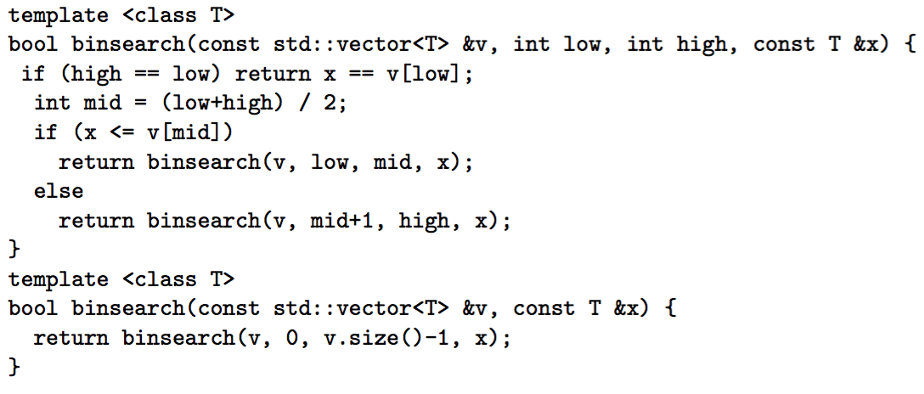

List functions

List.erase(iterator) iterator points to next position

Return positon of erased iterator

List.insert(iter, n) insert n before iter, iter x change

List.push_back(n)

List.push_front(b)

List.sort(help_function)

List.begin() return first iter; List.end() return last iter

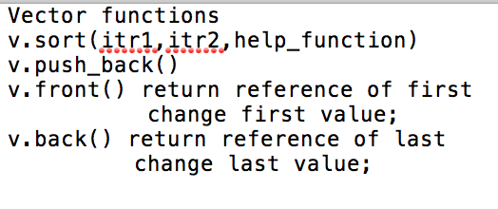if const list/vector, const iterator

Order Notation

O (log n) dictionary lookup, binary search

O(n log n) sort

Merge sort: space O(n log n) Memory O(n)

Assert: assert(abcd == true);

const usage:

member function: a() const do not change variable of members,

and can only take const member

const int& a: do not change a

const int a: a cannot be changed

const int fun() returned value cannot be changed

const int* fun() returned pointers cannot be changed

cons int fun(cons int & a)const

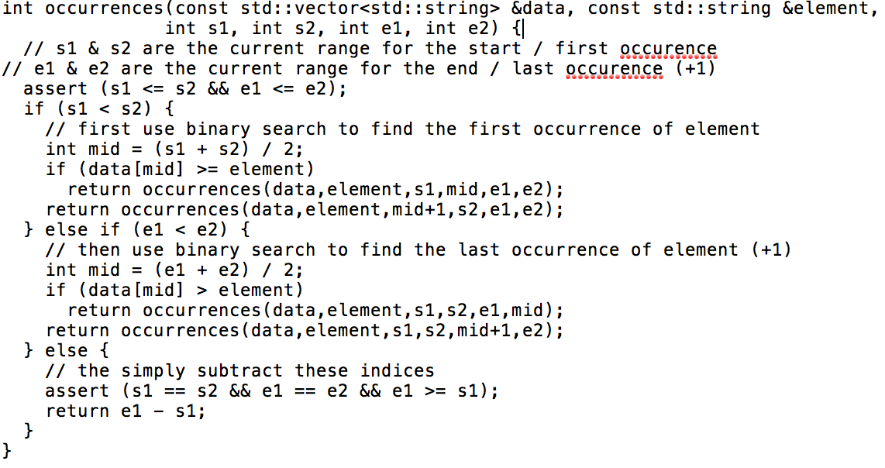recursion example

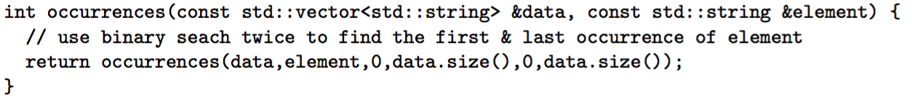

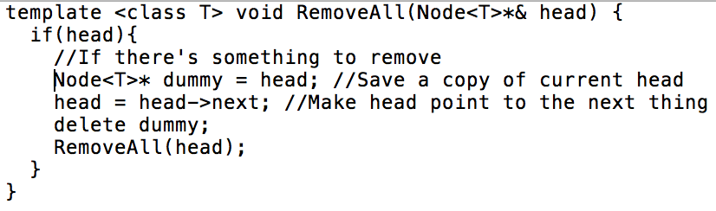iclicker

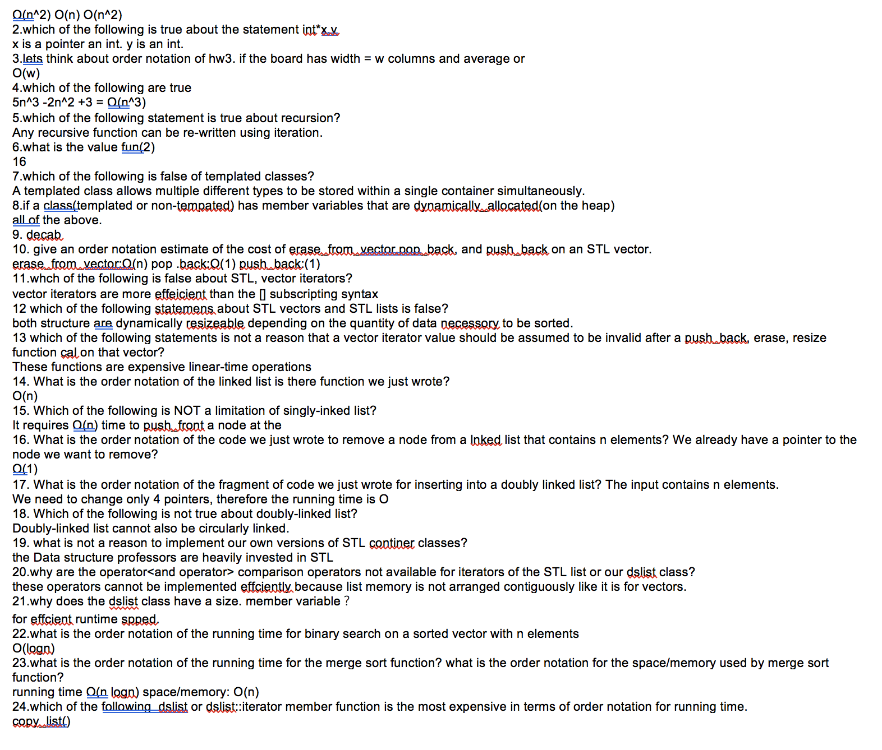1.what is the order notation of these 3 code fragments in term of n?

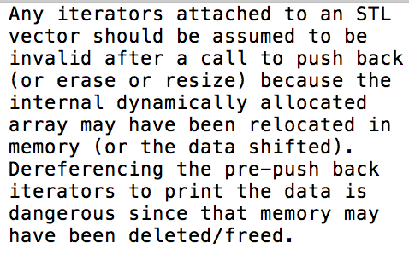

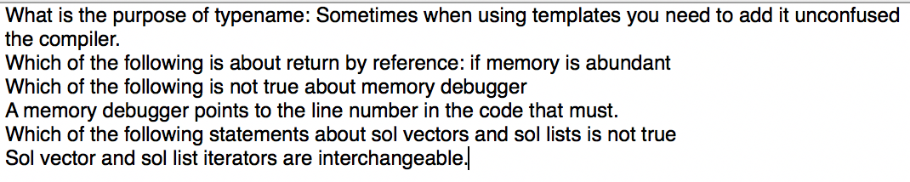

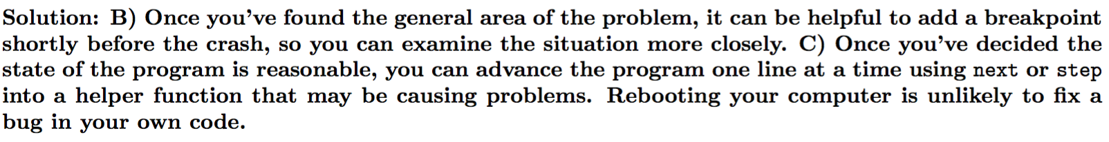

debug skills question at top of the first page.